St Hugh’s Foundation- Final Statement- Nisha Keshav
Thank you so much for giving me this invaluable opportunity.
I applied for this award as I felt my life had become stagnant creatively, since caring for my mother and then my clients living independently and supporting them and their families through end-of-life care, especially over the Covid lockdowns years.
My objective was to return to Holme Fen, for which I was offered a solo show at the Peterborough City Museum in 2015 after winning the Maxwell Memorial award.
My aim was to record the changes of the Great Regeneration project of the Fens and crucially reconnect back to my creativity and myself.
Returning to Holme Fen felt like a coming home, the familiarity was welcoming, comforting and healing.
I noticed many positive changes and an increase in the wildlife and the wild bird population from the regeneration project, the fen is still being farmed currently. Often, I would see a barn owl at dusk, (sadly I do not have the lens to capture the owls hunting), flocks of waterfowl, lapwings, starlings, and Chinese water deer grazing in the fields.
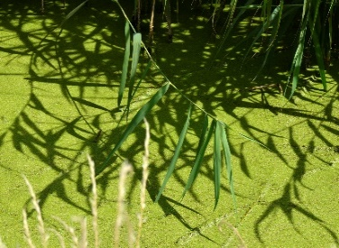
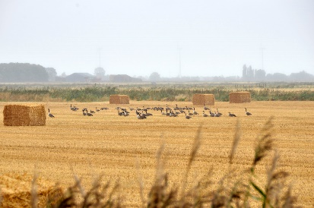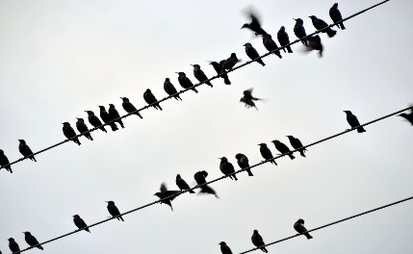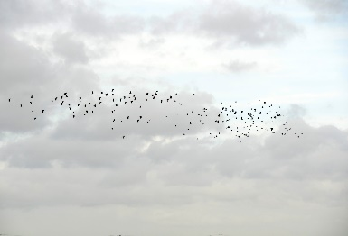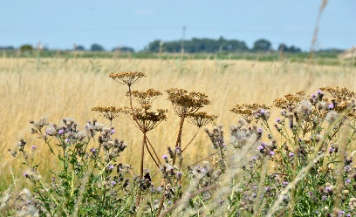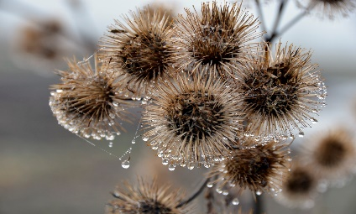
Once I started photographing, my concern was that I would be photographing the same landscape and views I had in my previous project and exhibition ‘Lines in The Landscape.’
I decided to approach this project from the point of view of the farmers who had helped shaped Holme fen.
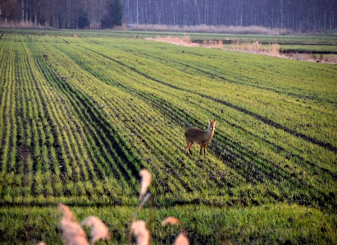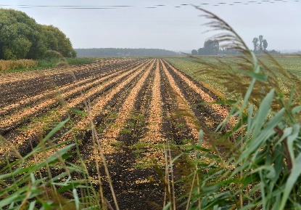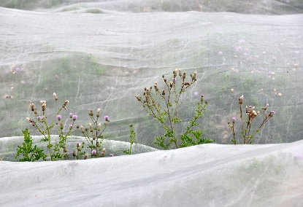

Sadly, my attempts proved to be futile, I could not find any farmers’ contacts. I contacted Natural England and Wildlife Trust who manage the nature reserve and responsible for the regeneration project.
After many weeks, I was finally contacted by Paul Trevor of the Wildlife Trust. He kindly showed me around and talked about the changes and the Regeneration was having on the fens, I had asked him if I could have permission to talk and photograph the farmers and he said he had asked them and they declined as they were too busy and did not want to be involved, I was very disappointed but carried on going to Holme Fen through recording the changing season and the changes in the farming calendar, inspired by David Hockney’s landscapes of Yorkshire through the seasons.
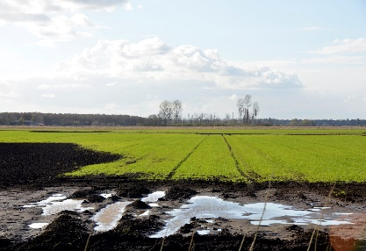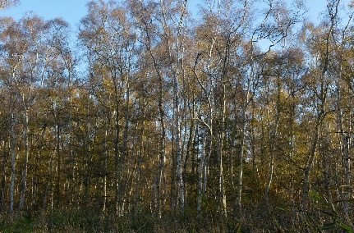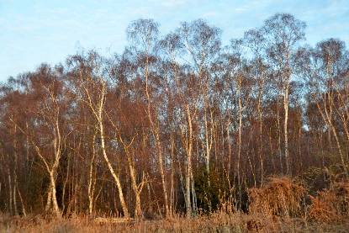
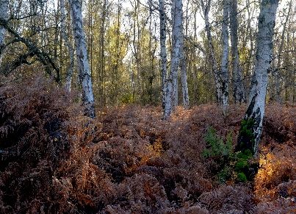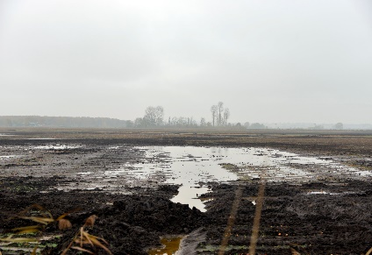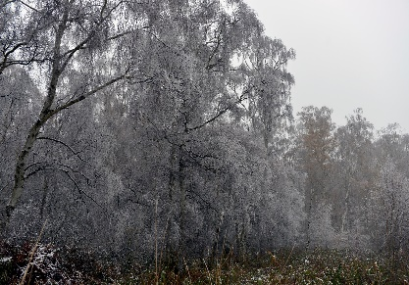
I have been inspired by Mark Rothko’s work and how his work allows the viewers to find themselves, I feel that the landscape of Holme Fen helps me get in touch with myself, especially as over the year I have two lost two close friends to cancer and had my own health challenges.
Going forward, I would like to explore the landscape of Holme Fen through painting, as I think my style of photography is quite painterly.
I am inspired by the late Scottish, landscape painter James Morrison (1932-2020). I love his landscapes of Angus with which he is most associated, the wide horizons, big skies, hedgerows, and rivers. The documentary ‘Eye of the Storm’ is a fascinating exploration of what it means to be a landscape painter. It is a poignant film which movingly intertwines Morrison’s struggle with old age, with his lively views as a much younger painter, captured in remarkable archive filmed more than 50 years ago.
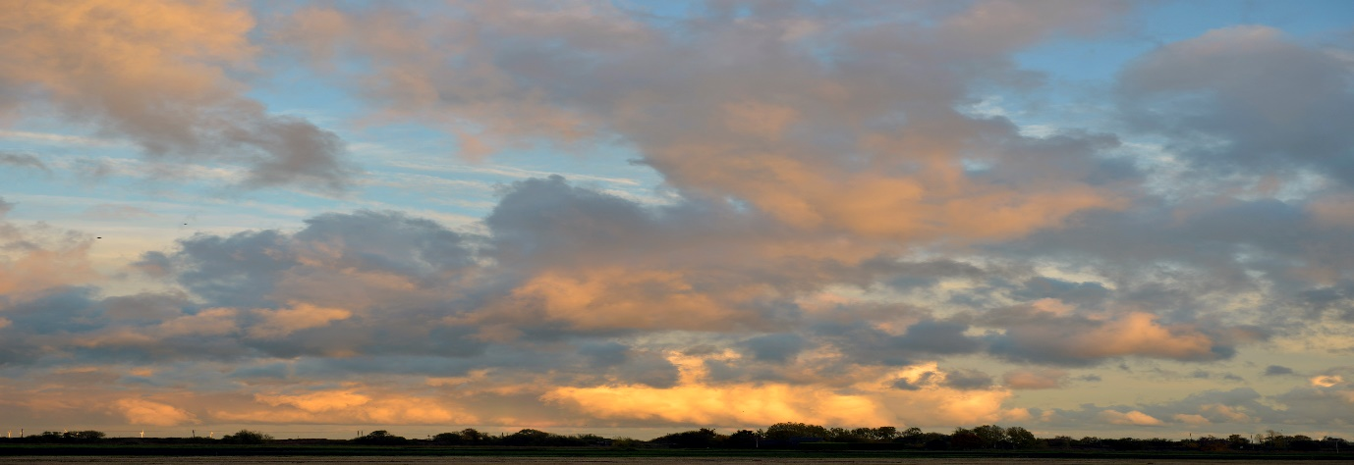
In hindsight, although documenting the lives and work of the farmers would have given a new perspective to my project, not being able to get permission helped me personally as my primary objective in my submission was to begin to reconnect with my creativity, which I feel it has done, I was able to go to Holme Fen when I wanted, when I saw the weather and skies would be dramatic or and needed to go and photograph just to de-stress myself to rather than working around appointments and the farmers schedule.
Prof. Tim Ingold very generously wrote the introduction to my ‘Lines in The Landscape’ the result of my study on Holme Fen solo show at the Peterborough Museum and Art Gallery in 2015.
A small quote from his introduction – “Nisha Keshav has proved, beyond doubt, that those who say that lines are but figures of thought, without any counterpart in the inhabited world, have got it completely wrong. There are lines in the landscape. Indeed, these photographs offer vivid testimony to the fact that every living landscape is no more, and no less, than a composition of lines and the elements”
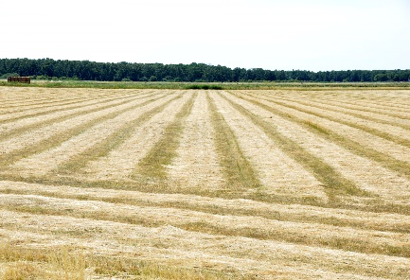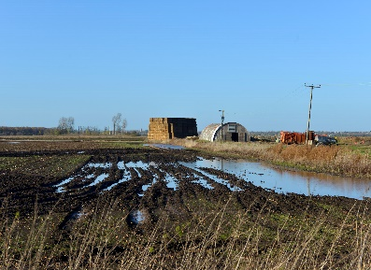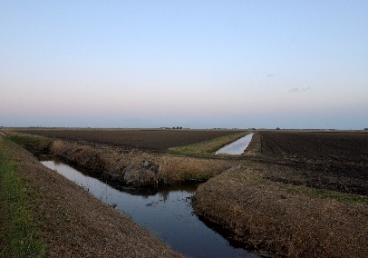
I recently went to the Tate Modern to see the Hilma Klimt and Piet Mondrian’s exhibition and was encourage to see that Piet Mondrian is quoted as saying ‘… I believe it is possible that, through horizontal and vertical lines constructed with awareness, but not with calculation, led by high intuition, and brought to harmony and rhythm, these basic forms of beauty, supplemented, if necessary, by other direct lines or curves, can become a work of art, as strong as it is true.
I find that even now I am drawn to the lines, both vertical and horizontal within the mesmerising landscape of Holme Fen. Holme Fen also has a thriving nature reserve over 657 acres of landscape and one of the finest natural birchwood forests in the U.K.
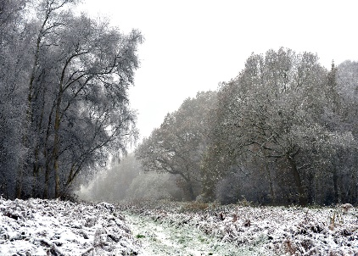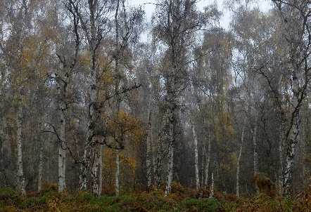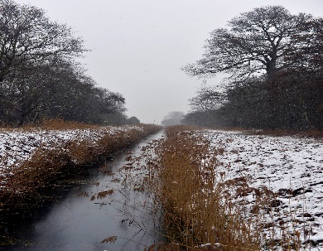
Each season reveals the beauty and majesty of the landscape and forest, my approach was to capture the changing seasons and translate through my images the mesmerising, spiritual and meditative act of working in solitude in the stillness and the stark beauty of this sublime and sometimes unforgiving, but often maligned and ignored landscape of the Fens
Nisha Keshav Photographer: www.nishakeshav.com

