Clare Peasnall Award Evaluation.

Kate Genever

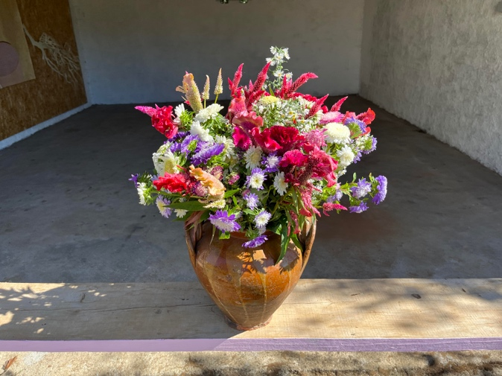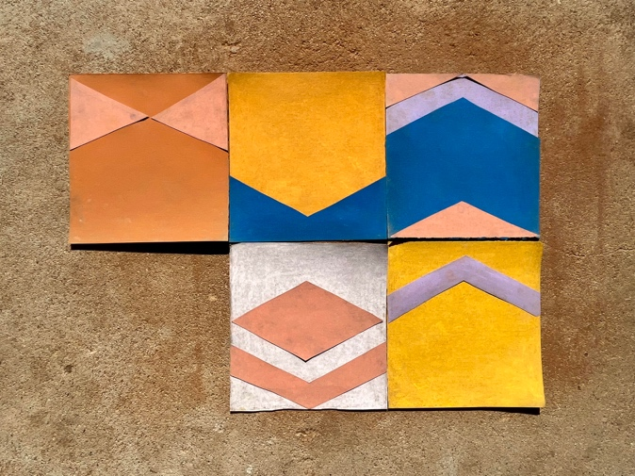

What I proposed
I have been invited to take part in an artist residency at an Olive farm in Tomar, Portugal in June 2023. The accommodation and living expenses are covered so I would use this award would support my travel. Which given I no longer fly, for environmental reason, is prohibitively expensive, but excitingly ripe with opportunity. Each way includes a 30-hour ferry trip, a 760km train ride and a stopover in Bilbao.
My work is site-specific and part of the landscape and still-life tradition. I embed myself in rural and coastal settings focusing on the industries, people and place. As a farmer, as well as artist, my work considers agriculture, improvised DIY technologies and land use. I often describe these as “ordinary things that are extraordinarily representative”.

I want this trip to challenge my practice in many ways. Firstly as an opportunity to be inspired by travelling itself - the journey I will document in a series of drawings. While a visit to Bilbao will enable me to visit important collections for the first time. Before the 3-week residency supports an intense consideration of working landscapes that I suspect look, feel and smell very different to Lincolnshire. My aim is to create a body of work using chalk pastels - instead of my favoured ink and charcoal - that describe the richness of the region, the textures of the land and the labouring peoples every day. All showcased at an exhibition in Tomar that reflects my explorations and experimentations.

Return train to Portsmouth 98.00
Return ‘economy’ ferry to Bilbao with compulsory sleeping berth 614.00
Hostel accommodation in Bilbao [2 nights total] 100.00
Return Train from Bilbao to Tomar 93.00
Art materials 95.00 Total 1000.00

What I actually did?
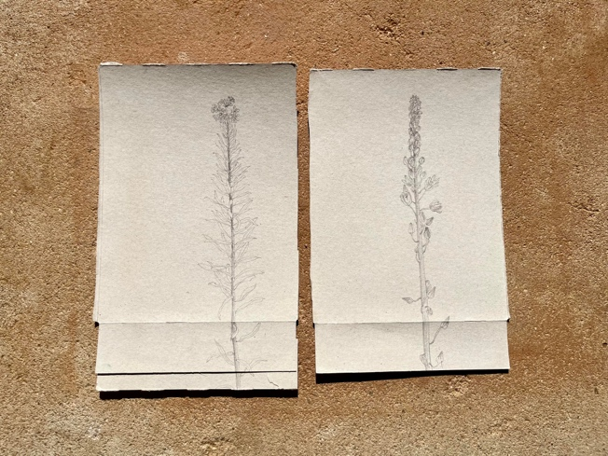
A 30 day round trip of 2294 miles involving the crossing of 5 countries (England, France, Basque, Spain and Portugal) using trains, taxis, buses, carpooling and my feet. Which allowed me to meet kind, generous and often very funny people, learn fascinating histories, experience local culture and practices, feel glorious weather, see diverse farming practices, nature at its best, depopulation, over population, the effect of climate change and lots and lots of art. And of course I also made some too!

As proposed the journey became part of the wider exploration. I drew as I travelled and in the places I visited on the way. This enabled me to not only capture the experience but also shake off previous ways of working as I searched for an approach that fitted these new contexts.
I spent 3.5 days travelling to and from the residency. On the way there I spent time in Salamanca, exploring important architectural sites of this Medieval city. In Porto on the return I visited the famous tiled churches and art galleries, where I discovered important Portuguese artists that seem to have passed over in the consideration of European art histories.

I then spent 2 weeks in Tomar [Instagram @studio459tomar] immersing myself in the Portuguese landscape, their farm and barns. Along with an exploration of the traces of current previous owners labours and their improvised tools. I walked the local landscapes, discovered further farming practices, water sourcing and saving, the growing and harvesting of cork oaks, ways of life and places of belief. I was also taken on trips to convents, aqua ducts, art galleries, ceramic museums and devotional sites, these in addition to artist workshops, and local towns. All of which informed the content and style of work.

My proposal also stated I wanted to work with colour. A thing that always seems so hard in the UK. Yet it seemed to come naturally, the cliché “the light” turns out to be true! It seemed impossible to document anywhere or anything without colour. The blue sky, painted houses, on tiles, the tomatoes, persimmons, grapes and wildflowers, even the ochres and yellow soil all bring colour to the fore. Couple this with the freedom of time and space for experimentation and I am now it seems a colour convert…
I used the soil and ash from fire sites as a ground on the paper and then continued with pastels. I create both large and small drawings, on found paper and cards, which worked as a collective whole. I created still life set ups and worked extensively with collage from memory. I incorporated natural materials into the work. Including flower arrangements made with two local gardeners. I installed all this work into a small exhibition in one of the barns on site. A series of photos, that I consider to be part of the final work in their own right, I was unable to print but these feature within the whole which I’ve titled “A tentative piece of ourselves that we stake at the boundary.”

I think the work considers the fundamentals of existing in a landscape – a downward digging and an upward building. It references wells, cisterns, threshing floors, tables. It speaks of the land itself and how it or we change it. But also then it also elaborates, as the folks of Portugal and Spain do, into pattern, colour and surface. I have been keen to think about how, in direct opposition to Northern Europe, the 'patternisation' and use of colour on building exteriors, ceramics, interiors, textiles, exists in everyday life. I wonder is it form following function or form following wealth or form following god? Whatever the answer I know that in the most humble of places much joy is derived from it. I can’t see that joy as anything other than life affirming and life giving.

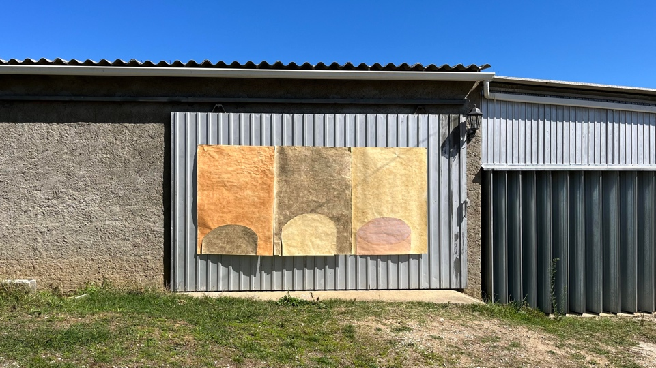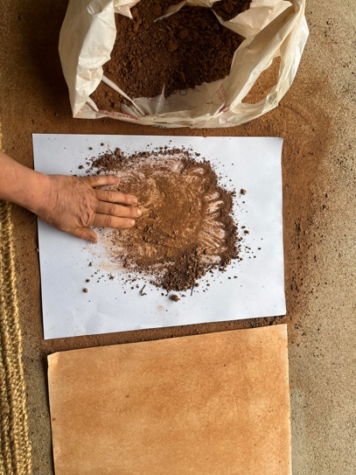

What I learnt?

The original idea of taking a ferry became impossible, practically and economically. Which meant I rethought and planned accordingly which was timely and often frustrating. It all led me to new routes and the excellent long-distance carpooling company BlaBlaCar. A discovery which helped with cost and enriched the journey because of the passengers and the places I saw.

Cost of slow travel is extraordinary in relation to flying and I can now show this as fact. I could have made the trip cheaper by staying only 1 night in either Salamanca on the trip down and Porto on the way back but still the journey would have taken 2.5 days each direction. Of course the benefit of this type of journey is opportunity to see and explore incredible cultures and histories.

Slow travel using public transport needs not only funds but imagination, determination, trust, patience and courage. Google translate was a god send! I feel completely empowered by undertaking this journey and keen do more.

By using public transport and more environmentally friendly/collective transport systems I have met kind, generous and often very funny people and seen parts of the world very few see or know. As I wrote in an Instagram post : This very long road trip is like a modern-day Grand Tour - without the bag carriers and official tour guides!!! Which has meant yes I’ve got stressed about connections, confused about directions but mostly, brilliantly seen overlooked places, met kind interesting people, learn about animals, birds and incredible weathers, while also experiencing landscapes, traditions and cultures impossible by another way. Yes it’s costly, in time and money, prohibitive to many, but without doubt important for the planet, soul and intellect. I reckon If we don’t know what we fly over how will we ever love it enough to demand change about how travel can work?.

Rural, France, Spain, and rural Portugal are amazing places. They are beautiful and fascinating, environmentally challenged and stressed, enriching and inspiring. I enjoyed learning more, experiencing their scale and I feel positive in supporting them as they struggle to find new ways to cope with the climate emergency and depopulation.
- A residency allows for a stepping away from “real life” which brings a focus and opportunity for exploration and experimentation. Meaning I’ve learnt things about making and subjects that are very different from home, which has brought new ideas and challenges. These things are useful and allow the work and me to improve.
- International residency’s are important but so too is the environment and being in a rural settings further reminded me that we must not forget how cheap flying travel is unsustainable. How we balance the two is the hard question.
- Slow travel has informed the work as the act of exploration was central to the whole trip.
- I can work with colour! For a long time it has evaded me , making only limited appearances. Working directly with the soil, found colour or in settings where light impacts I can now understand how I might use it in the UK. I have come to see and begin to understand my emotional connection to colour. And how when working in sites where I experience freedom, joy and care it becomes possible as I become less burdened.
- This award has provided me an opportunity that I’ll never forget. It has enabled me to nurture my curiosity, explore new places, experiment with materials and methods and informed how I make and do. I’m grateful for every minute.

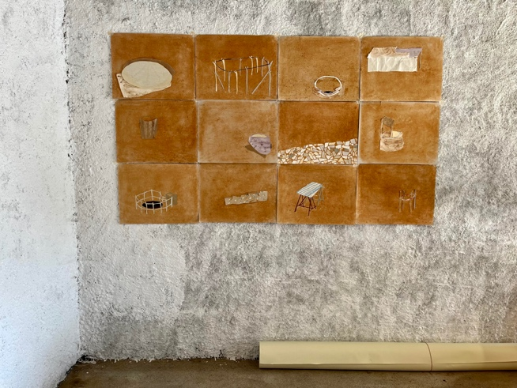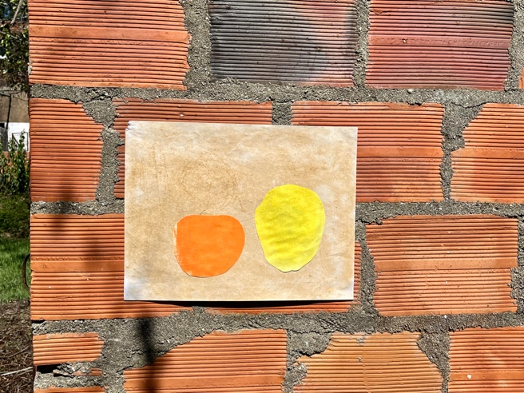

What’s next?
The new work looks very different to work I normally make and that seems to offer new potentials now I’m back in the UK.

Directly I am going to work using the photos I’ve taken to generate new collages made within the computer before being printed out. I can imagine how these become starting points for a series of handmade carpets or textiles. I am keen to try a tufting gun that allows you to draw directly into a stretched textile. I would be interested then in showcasing these objects alongside 2D drawings and photographs at a site as yet undecided.

I am interested in continuing to use flower arrangements [by me or others] in the work. Perhaps for this to become a project on its own. It builds on socially engage work I am doing elsewhere but can now see how outcomes could be part of a gallery context.

While in Tomar I also made a contact with a space that shows work by artists who have responded to the local environment and culture. They were interested to talk more about my work and how we might show it there. I plan to develop this and aim for a display of works in early 2024.

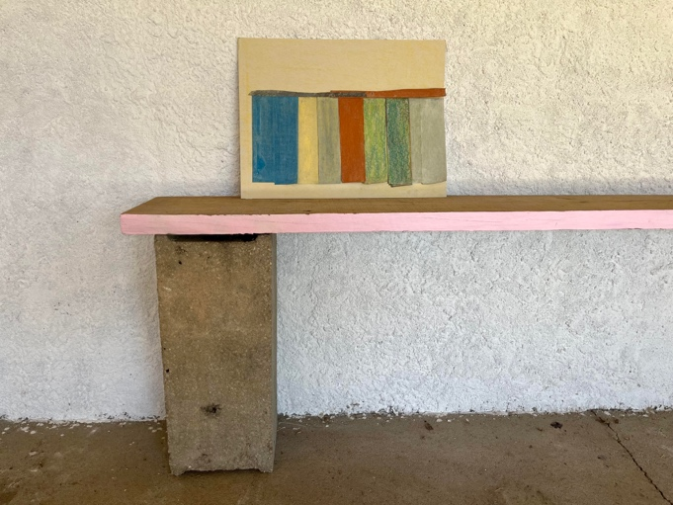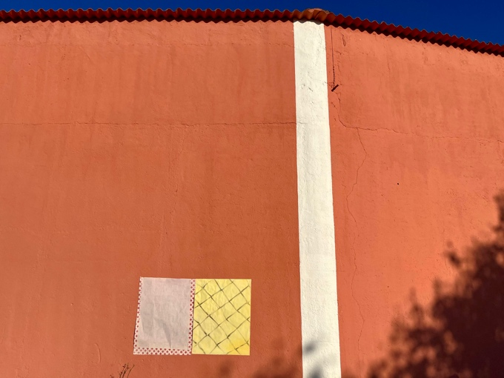

Actual Costs
2 return tickets to London 46.00
2 return tickets to Paris via Eurostar 166.00
2 taxis across Paris from Gare to Nord to Montparnasse 55.00
2 return tickets Paris to Hendaye France 150.00
2 Hotel nights in Hendaye 150.00
Hendaye to Salamanca via BlaBlaCarpooling 26.00
2 nights Salamanca 103.00
Bus from Salamanca to Tomar 32.00
Tomar to Porto train 20.00
Porto hostel 2 nights 60.00
Taxi to meet carpool for return to San Sebastian 20.00
BlablaCar from Porto to San Sebastian 39.00
Train from San Sebastian to Hendaye 3.00

Art Materials purchased in Tomar 30.00
Contribution to petrol/trip during residency 100.00

Total 1000.00

Further info
See the following for further images.
Website: Kategenever.com
Instagram @kategenever
The place I stayed can be best found via their Instagram: @studio459tomar

